Electronic Supplementary Materials

Online Material 1: Supplementary Figures

Fig S1. Representative spectra of the experimental flask of strain CCMEE 5410 before and after nitrogen starvation. Nitrogen starvation occurred from day 1 to day 7. On day 7, the culture was transferred to nitrogen replete conditions.

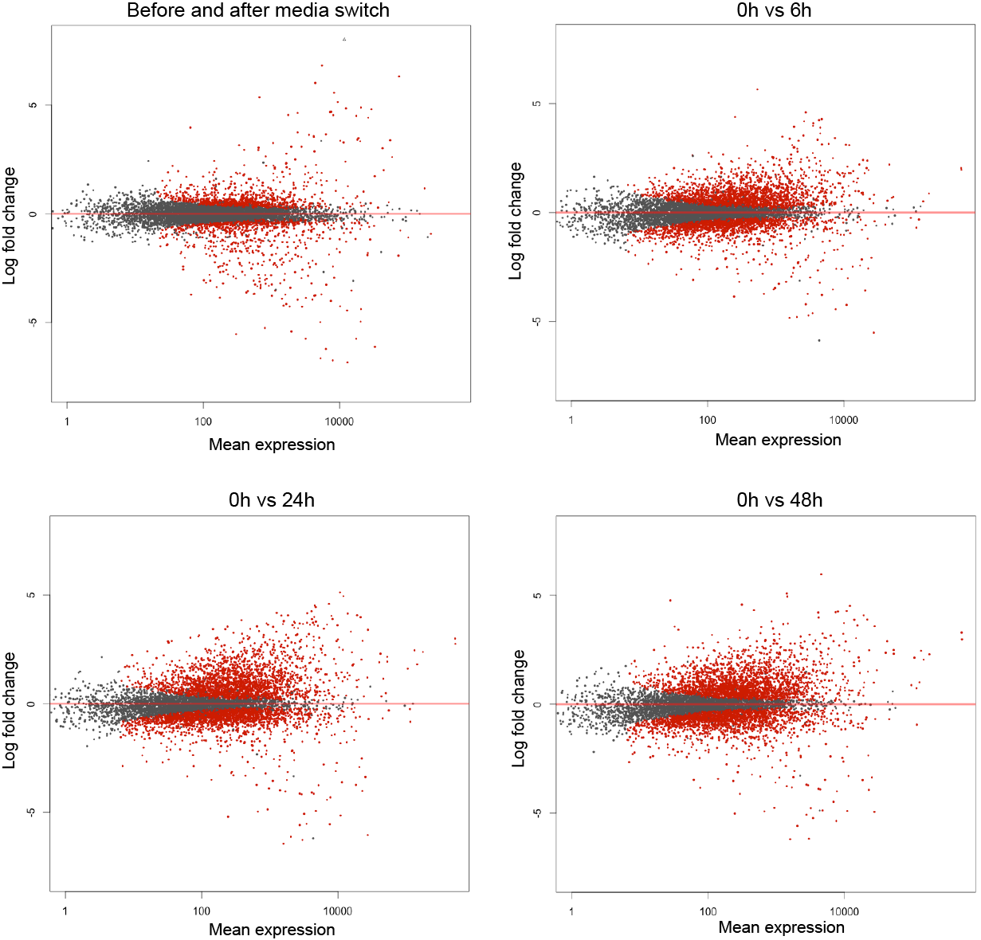
Fig. S2 MA plot showing global gene expression change
Each dot represent a log2 fold change of a gene plotted against mean expression (baseMean) using plotMA function of DESeq2. Red dots indicate genes with significant adjusted p value (padj).

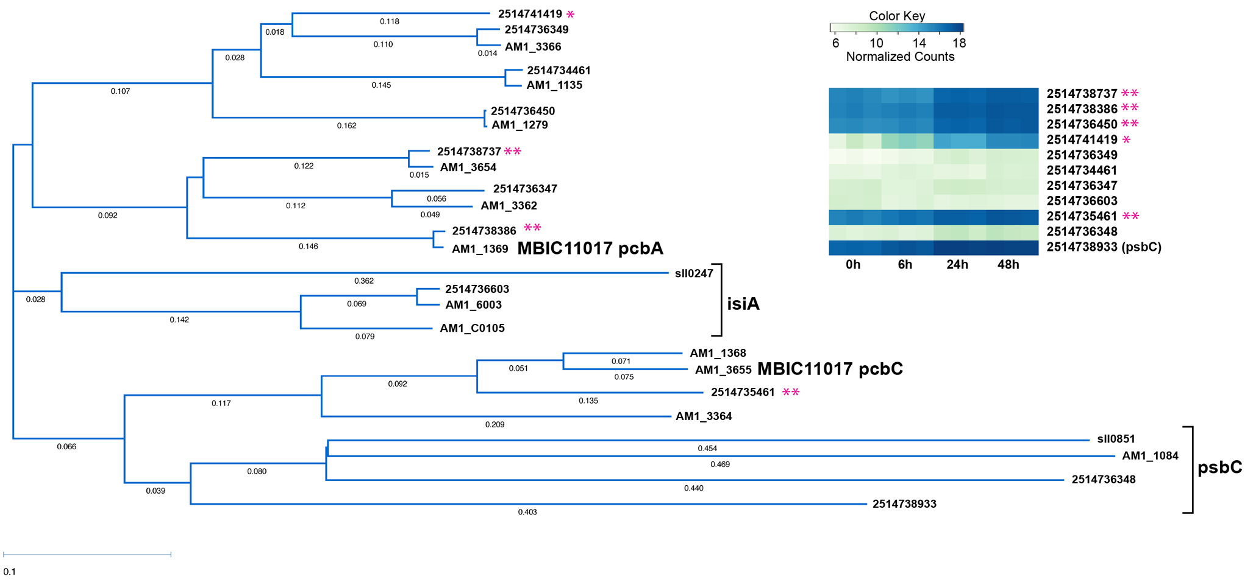
Fig. S3 Phylogenetic tree of pcb homologs. Four major and one minor chl a/b-binding protein homologs are upregulated and highly expressed, and are distinct from psbC and isiA-homolog (AM1 annotations are for MBIC11017). **, putative chl d-binding protein genes (major transcripts); *, minor chl d-binding protein gene (minor transcript, no homolog in MBIC- plasmid encoded?)

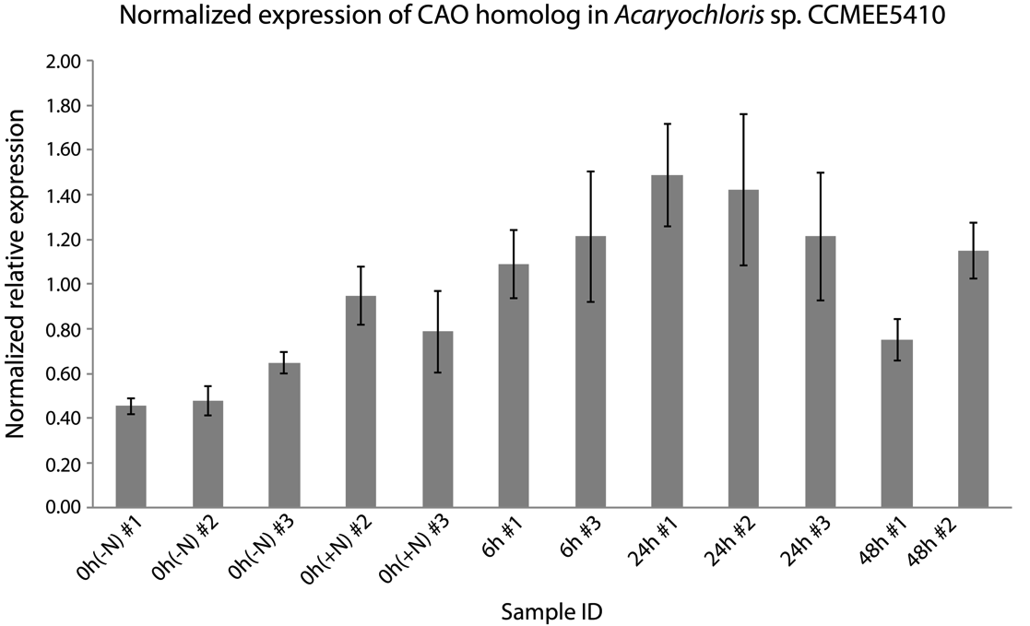
Fig. S4 Normalized gene expression of the CAO homolog, 2514737811 in Acaryochloris sp. CCMEE 5410. Quantitative PCR was performed to confirm RNA-Seq data, using primer sets to the gene 2514737811 and normalized using 16S rRNA abundance. Gray bars show normalized relative expression per RNA sample. Error bars indicate standard error of mean from triplicate qPCR reactions. The number under each condition indicates the specific replicate tested.

Online Material 2. Summary of RNA-Seq
An excel file containing lists of comprehensive genes with DESeq2 analysis information, and lists of Gene IDs for genes mentioned in the manuscript.

